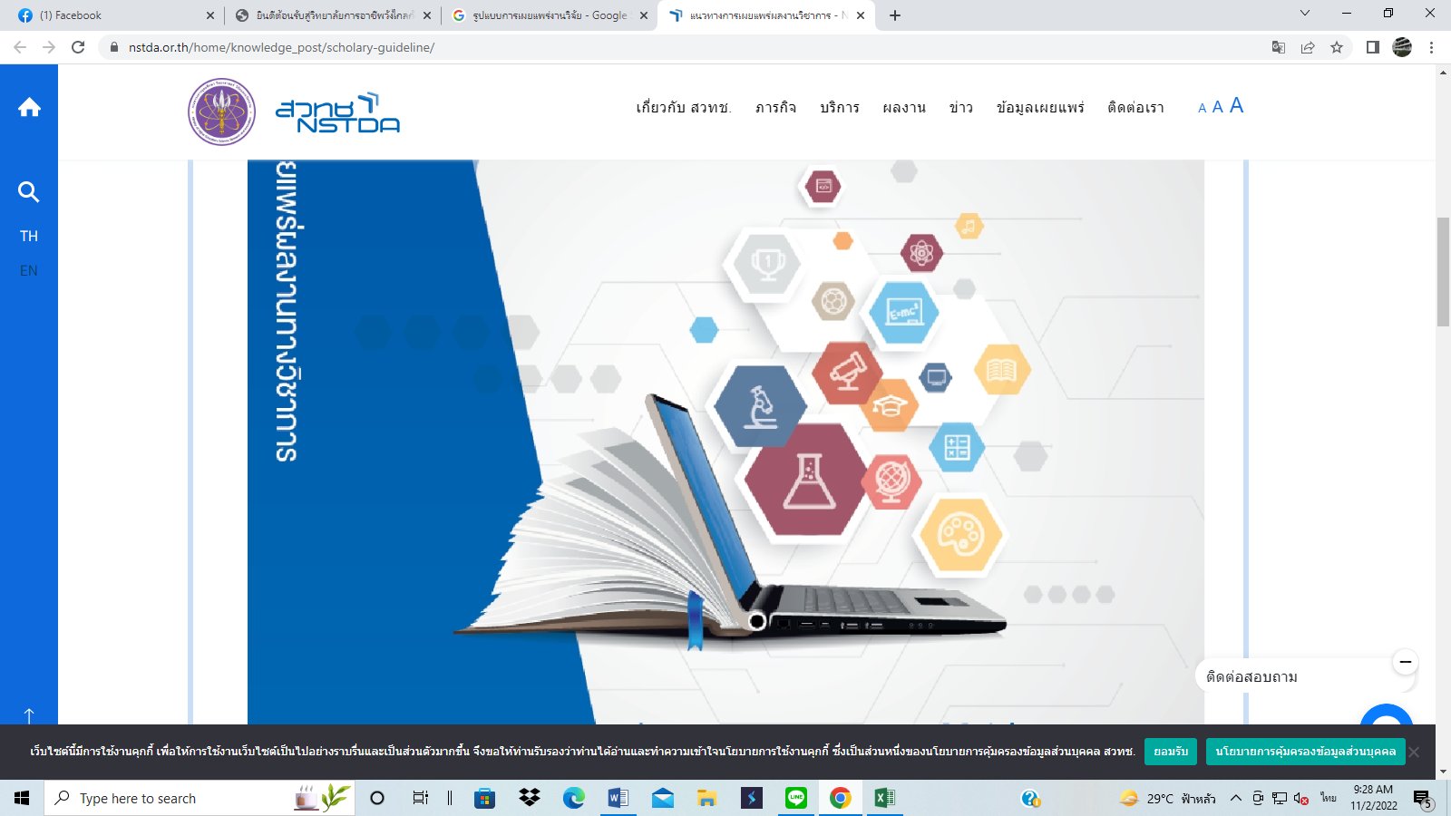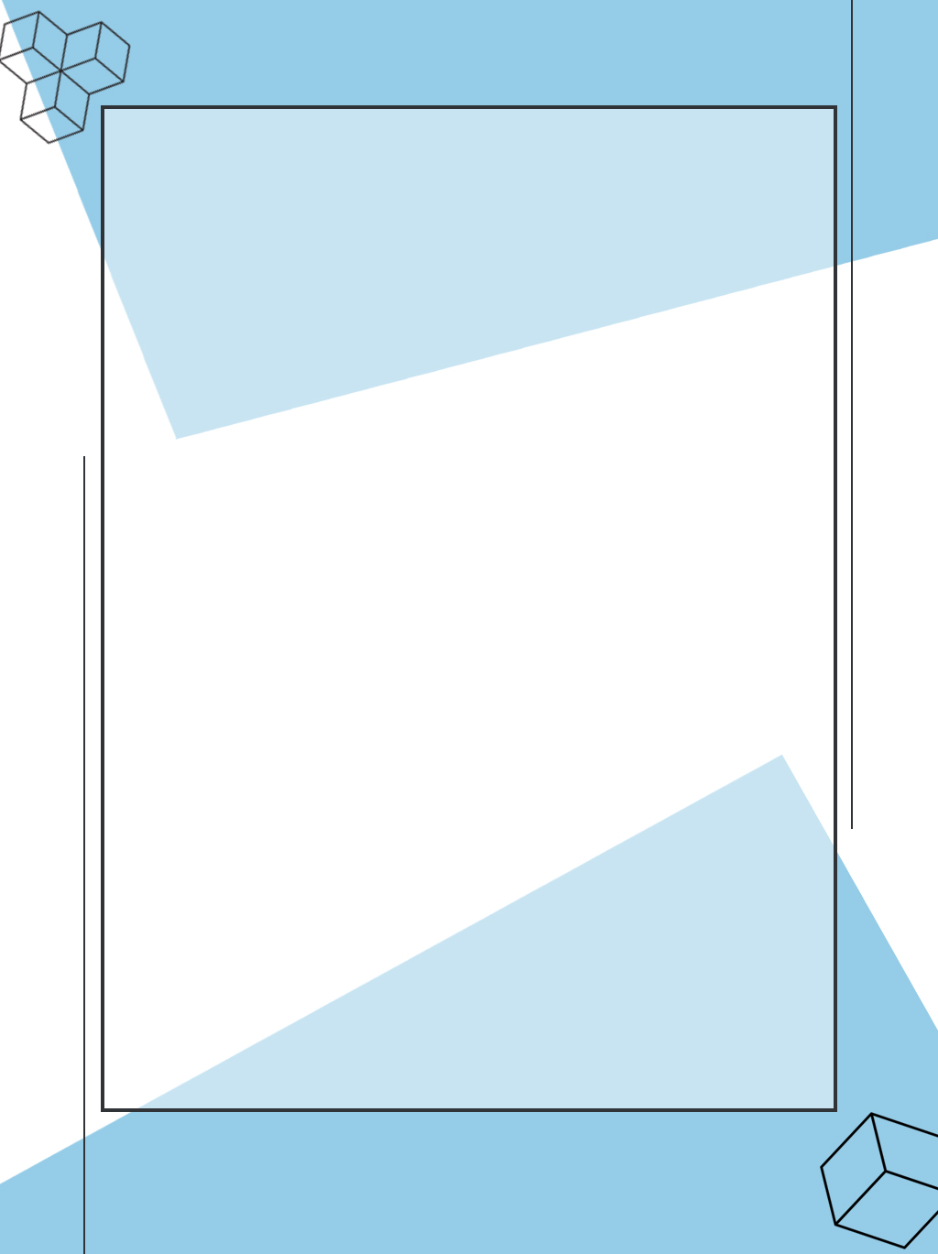

**เอกสารดาวน์โหลด**

[**https://drive.google.com/drive/folders/1u3pgxLpWYlShlkQn4jd6zVXENw2Hk5zo**](https://drive.google.com/drive/folders/1u3pgxLpWYlShlkQn4jd6zVXENw2Hk5zo)